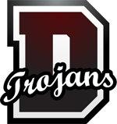
Dougherty Comprehensive High School
October 2018: Monthly Report
Prepared by Alicia Evans
Part A: Program Evaluation
Executive Summary
The Dougherty Comprehensive High School Media Center is home to both the school’s library as well as the hub of technology resource center. The media center houses fifteen computers which can be used by staff and students. The medial center also has print and digital research materials for students and teachers. It is conducted by one media specialist and one media specialist paraprofessional. The media specialist runs the media center and teaches classes to 9th and 10th graders. In her session with the 9th and 10th graders, she shows different ways to research material, how to cite information and the difference between factual and nonfactual information. She also addresses technology issues for staff, administrator and students. The media specialist also provides staff development for the faculty and staff once a month with the emphasis on Web 2.0 tools that can be utilized in the classrooms. There is one technology lab that holds twenty desktop computers for anyone in the school to use. Dougherty only needs one lab because in their school system each student is given their laptop or tablet for school purposes for the entire school year. The Multimedia and Business Technology Classes mostly use the technology lab. The Multimedia and Business Technology classes are two classes that offer a three-year pathway for students to get a pathway endorsement. In the multimedia class students work on creating videos, green screen productions and they are the producers of their school news show called Trojan Nation TV. In the business technology class students work on Microsoft suites like PowerPoint, Excel, Word, OneNote, and SharePoint. In the end, the three years students will become certified in Microsoft Office.
The media specialist of Dougherty Comprehensive High School is focused on upholding the mission and goal of the school and Dougherty County School system. She works hard in supporting her staff members and students with technology literacy skills as well as literacy skills for the students. The staff members at Dougherty speak very highly of her and respects her with the job she holds. Additionally, staff members are in need of more staff development opportunities to improve their skills in the area of using appropriate tools to engage students.
The technology center evaluation was performed through observations, interviews with staff personnel, and review of the job description.

Organizational Chart
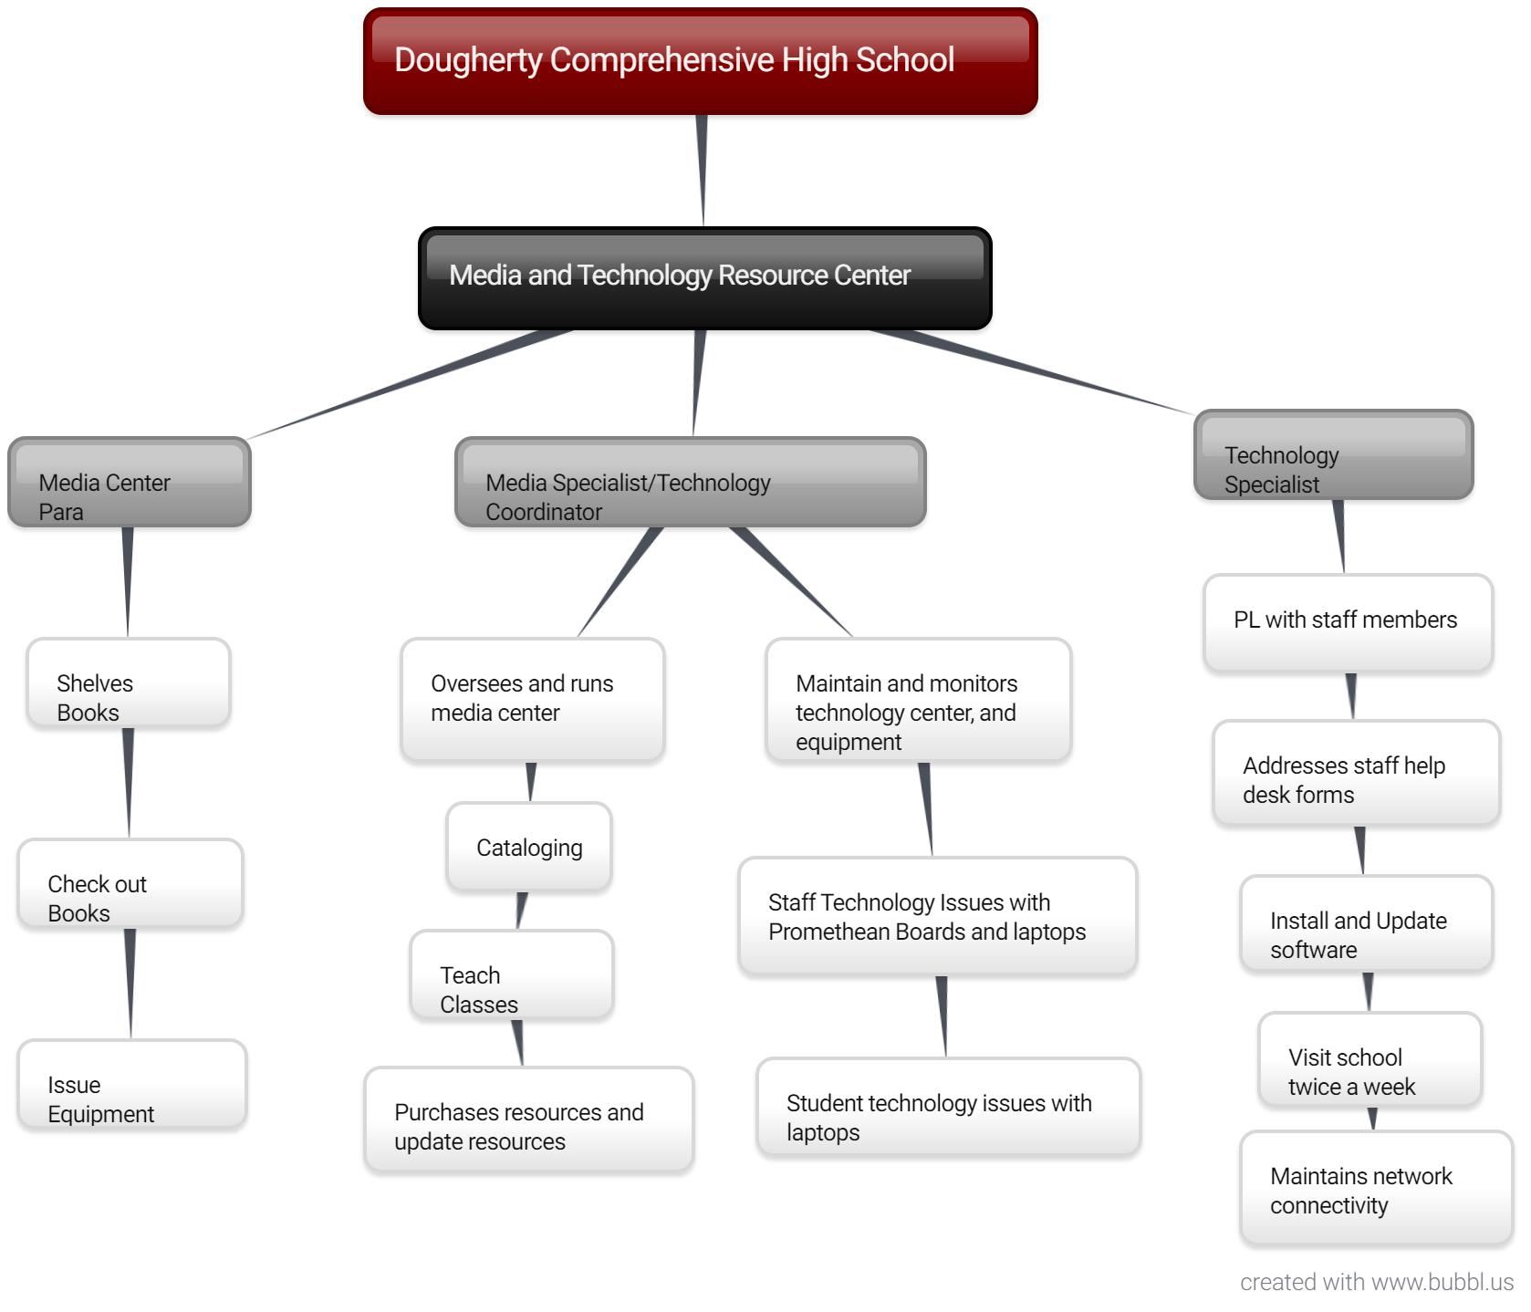

Methods
While constructing the report, multiple methods of data collection were used. During October, fifteen hours of observation took place at the center. Interviews were conducted with the media specialist, media center paraprofessional, staff members (Appendix A &B), observations of the media center and other facilities (Appendix C).
Center Context and Goals
The Dougherty Comprehensive High School was established in 1963. In 1980 the media center was built. The media center is an essential part of the school and helps support literacy and technology skills for the school’s 940 students. The center is open to students, staff, and parents every day from 8:00 am to 4:30 pm. The media center houses fifteen computers that can be used by students, parents, and faculty to locate research material, to complete resume’ and conduct research. Each student in Dougherty Comprehensive High School received their laptops for the entire school year. There is one technology lab that holds twenty desktop computers for anyone in the school to use. The Multimedia and Business Technology Classes mostly use the technology lab.
The media has had four media specialist. The current media specialist is Mrs. Dorinda Ouzts. She earned her Specialist in Media Technology. In 2003, she was in charge of the center, purchasing, cataloging, circulations and daily instructions of at least one 9th or 10th grade class. Based on collaborations with homeroom teachers and students’ needs, Mrs. Ouzts class can focus on how to cite material, how to research factual articles for essays, digital citizenship, and more. She makes sure she is incorporate any content needed for teachers because she is all about seeing students succeed academically. Mrs. Ouzts also is in charge of any staff related technology issues.
There is a paraprofessional in the media center, and his name is Darrell Jenkins. He helps run the circulation desk, shelves the books, assists in teaching the class, distribute laptop to students and teachers, and help with any students or teachers technology needs. Mr. Boykins is one of the district’s technology specialist. He is present at the school twice per week. He assists with all help desk questions. He also participates in the schools' collaboration meeting and gives professional development to those teachers who are need of more instructions on different technology applications.
Mrs. Ouzts mission at Dougherty High is to implement educational strategies and develop an enhanced communication dialogue with students, parents, staff and the community that will effectively enable all students to reach their maximum potential academically, socially and emotionally.
Ms. Ouzts provides the goals of the media center upheld by the district. The goals include:
• To provide materials and services which meet the information and recreational needs of the learning community.
• To provide opportunities for collaboration between the library media specialist and classroom teachers to incorporate information literacy into instruction.
• To promote information literacy.
The media center’s stakeholder includes students, parents, staff members, and administration.

Center Activities
The center offers classes daily to different classes. The classes take place in the media center. For her instruction, she usually uses Nearpod or PowerPoint to drive her instruction. All during the day she is steadily checking out books for group collaboration, research in classes, ethical use of information with digital citizenship and the need for resource checkout.

Evaluation
It is very evident that Dougherty Comprehensive High School Media and Technology Center plays an essential part in supporting the school’s mission of promoting academic excellence and ensuring all students have an equal opportunity to learn in a supportive learning environment. The school and the district are committed to integrating technology into student’s academic lives is being upheld by the media center, the business class, and the multimedia class, that helps students gain lifelong skills. Students are using laptops, Promethean boards, and desktops on a daily basis. The media center provides support to all stakeholders in literacy and technology.
Observations show that Mrs. Ouzts is demonstrating the requirements of the media center. She goes over and beyond her call of duty for the students, teacher, administrators, and parents. Mrs. Ouzts’ paraprofessional is also a great asset to her team. Mr. Jenkins is very helpful to Mrs. Ouzts and is constantly handling other problems or activities when Mrs. Ouzts is available at that time.
An additional suggestion I would recommend is further professional developments for staff. Making sure that staff members are comfortable using and navigating through different technology tools. Also teaching more engaging technology tools that will be beneficial and engaging to the students.

Appendix A: Interview Questions for Media Specialist
- Can you provide a brief history of the center?
- What is the mission of the center?
- What are the goals of the center?
- Who are the center’s stakeholders?
- What are the job titles and responsibilities of key personnel who staff the center, including yourself?
- What is the current status of the center?
- What activities are carried out by the center?
- What is the purpose of each activity?
- Where are activities conducted and who is the audience?
- What technology tools are available to staff members and students?
- In what ways do you support staff members use of instructional technology?
Appendix B: Interview Questions for Staff Members
- How does the media and technology center support your needs?
- What technology resources do you have available to you?
- How quickly are help desk requests answered?
- In what ways do you and your students regularly interact with the technology center?
- How do you feel the technology center could be improved?

Appendix C: Center Observation Checklist
- Sufficient technology is available to staff and students
- Resources are well maintained, up-to-date, and working properly
- Technology literacy is promoted and supported
- Staff technology issues are addressed promptly
- Classes are available and offered to all students
- Media specialist collaborates with teachers to design effective and meaningful instruction that supports the center’s mission
- Media specialist regularly shares information regarding apps and web 2.0 tools with staff members

